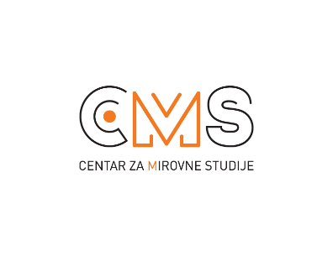
Selska cesta 112a, 10 000 Zagreb, tel/fax: 482 00 94; cms@cms.hr; www.cms.hr

Zagreb, May 14th, 2019.

INIVITATION TO THE PUBLIC PANEL:
Europe and Migration: Where do we draw the (border) line?
Centre for Peace Studies invites you to join us on Monday, May 20th, 2019 at 10:00am at HUB365, Petračićeva 6, in Zagreb, for the public panel: „Europe and Migration: Where do we draw the (border) line?“ where local and international experts will present and discuss the current migration situation, as well as the expectations that decision-makers at the local and European Union levels bring to an end the current human rights abuses, prevent the occurence of future abuses, and respect the rule of law.
Candidates for the upcoming European parliamentary elections have been invited to the panel.

“How are migration, human rights and security connected, and what critical points or challenges do we find at their nexus? Where does the EU stand on the question of migration and what can we expect from the Common European Asylum System? How to ensure a fair distribution of responsibility, respect for human rights and the rule of law?” are just some of the questions that will be discussed on the panel.

Representatives from Amnesty International, Human Rights Watch and the European Council on Refugees and Exiles will be speaking on the panel, offering their perspectives as valued and established international human rights organizations, independent from any political party. Border security and human rights in the context of migration are topics that are evermore present in public debates at the local, regional and European levels.

We consider it important that in the lead up to the elections of the European Parliament, political debates also give voice to the experts and those working daily in the struggle for the respect of human rights and dignity of all persons. Further, it is essential to counteract with facts and evidence the very loud populist voices, as well as all forms of violence, racism and xenophobia that are increasingly present in the public discourse.

For more information, please feel free to contact Lovorka Šošić at lovorka.sosic@cms.hr or 0981898457.

