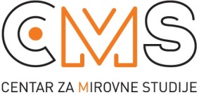Selska cesta 112a, 10 000 Zagreb, tel/fax: 482 00 94; cms@cms.hr; www.cms.hr

Beyond GDP: Measurement of Well being
Presentation and discussion with prof. dr. Andrea Bassi, University of Bologna, Department of Sociology
Venue: Human Rights House, Selska 112b, Zagreb
9:30-10:00 | Greetings: Sandra Benčić, Centre for Peace Studies  Introduction of presenter and participants  Andrea Bassi: Introduction: How macro (economic and financial data) shape our everyday life and Beyond GDP initiative –why do we need different models of measurement of wealth and well being  Q&A
10:00-11:00 | Andrea Bassi: The Commission on the Measurement of Economic Performance and Social Progress: From measurement of production to measurement of well being  Q&A
11:00-11:20 | Coffee break
11:20- 12:30 | Andrea Bassi: BES – How to measure Equitable and Sustainable Well-being: presentation of indicators and 12 dimensions of well being
12: 30-13:00 | Open discussion with focus on applicability on Croatia  Moderated by Marina Škrabalo
Participants: human rights activist and social researchers of inequality

